The Red and White Winter 2020
  - Overbrook School for the Blind High School Newspaper

My Summer at TVI
By Ethan
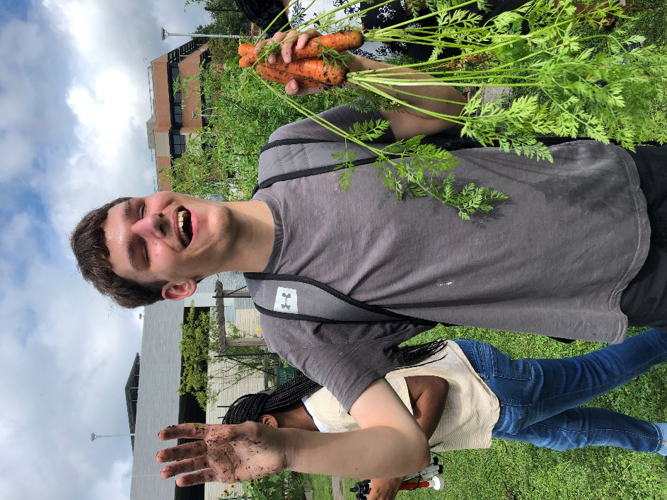
Last summer I participated in a summer program called TVI. The TVI stands for Transitional Vocation Initiative. It's a program that takes place here at Overbrook School for the Blind. A lot of people attended to and TVI and I was one of them.
When I attended TVI, I was nervous at first but then I got over it. I didn't know what to expect. I saw my old friends from school there and made some new ones along the way. The staff were very friendly, helpful, and supportive whether it was in the dorm or in class. The purpose of the program was mainly to get some work skills and job experience. But it was more focused on careers in general. During a 3-week period, we covered everything it takes to get a job from researching what kind of job you want, to creating resumes, job applications, personal data sheets, and disability statements. I also learned about how to prepare for a job interview.
TVI wasn't just about work. We also got to do some fun stuff. There were plenty of activities along the way, ranging from the ordinary to the extraordinary. The kinds of activities were rock climbing, tandem cycling, and feeling replicas of pieces and artifacts from Roman times. It was my first time rock climbing. I got at least 3 quarters of the way up. There were some people who believed they couldn't do it, but there were some people who did. Even though it was my first time rock climbing, it wasn't my first time cycling. I could already feel the wind in my hair. The breeze was nice and it was a very relaxing ride. It was also fun looking at all the replicas of the pieces from Roman times. One of my favorites was a set of kitchen ware. They consisted of a cup, plate and something to put the food on when it's cooking.
Also during TVI we went on visits to job sites and had some special guests come over to talk with us about different topics. One of the work tours we went on was going to Vision Core where we got to see how they make reflectors. We even got to experience building these from start to finish. Vision Core by the way is a factory built for the blind and visually impaired. One of the special guests that came to the program was one of our alumni, and that person was the one and only Elijah McClinton. He showed us how he makes mac and cheese. It was a long process but it was still worth it. For both the job site visits and the special guests, we had to write thank you letters explaining what our favorite things were about either the job site itself or the special guests.
TVI also worked with us on washing and drying clothes, cooking, cleaning and other independent living skills. But overall, I've had a great time at TVI. They even gave out certificates at the end of the program. When you go to TVI like I did, you'll have as much time as when I went there. The activities, job site visits, and special guests will vary from year to year depending on when you go. But other than that it's completely the same. So when you go to TVI, make sure you have the best time of your life, or at least try to. I'll never forget my days at TVI.
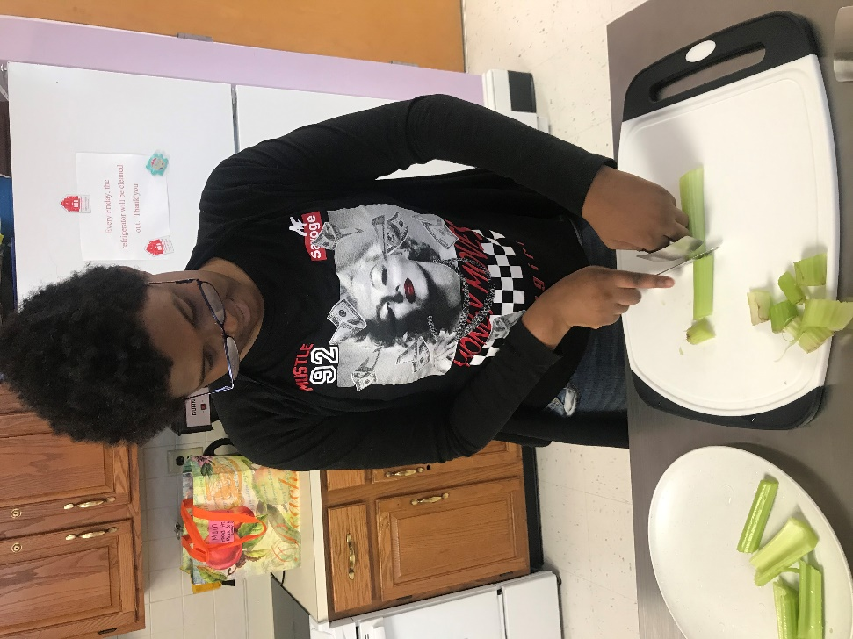

Teenage Fashion
By Marques
Fashion means you can dress and look good. Teenage fashion can be good for your life. Teenage fashion can be good for your life because when you look good, you feel good and you look confident. Teenage fashion is a good way to express yourself.

Fashion can help express your personality in many ways. It can express whether you look nice or not. Fashion can also express to people how you want to look. Fashion can also express how you feel. The way you dress tells a lot of things about you. For example, the clothes you pick can tell others you are professional, creative, and assertive.

Teen fashion is important to visually impaired people because even though they can't see what they're wearing, people still expect you to look your best. Teenage fashion is important to visually impaired people because even though you’re blind, girls and boys expect you to look nice when they ask you out on a date. Teenage fashion is important to visually impaired people because it's important to dress appropriately.

There are a lot of ways teenage fashion can become a part of your life. Teenage fashion can become a part of your life because people like it when you look nice. It's important that you can pick out your own clothes instead of letting your mom pick of clothes for you so that you can express yourself.

As you can see, fashion is good for you if you want to look good. People like it when you look good and I bet you’ll like it too. People also like it when you wear something fashionable. Remember, it's important to look your best so you can feel your best.

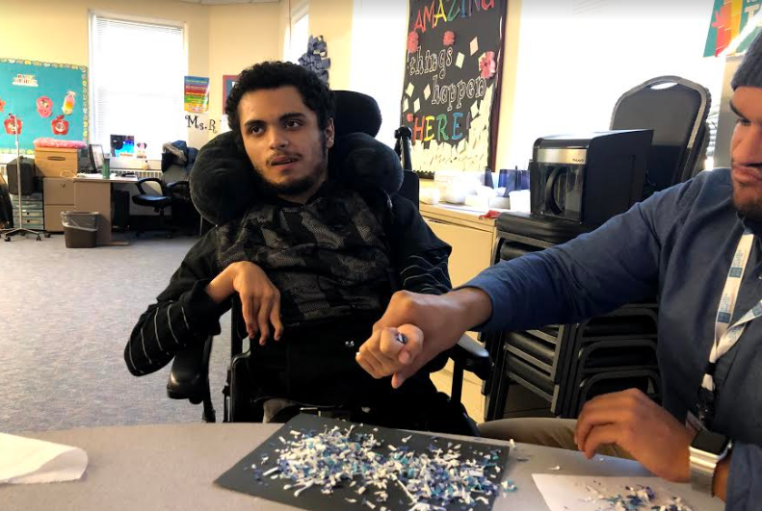

Knowing Your Way Around the Ball
By Gabby

Have you ever wondered how people with visual impairments play sports? Well, one special sport is called goalball and it was made for people with vision loss. It is very unique and fun to watch. Some people do not know what this sport is all about. Some people might say, “What is goalball”? Or, “how is it played”? Here is a little history of what goalball is and how it got started.

Goalball is a sport invented for people with vision loss. It was invented for veterans who lost their vision in world war II. It is played in 112 countries. This sport was introduced at the paralympics in 1976. Goalball continues to be an olympic sport still today. It is the only sport in the paralympics that isn’t adapted from another sport. This is the only sport that wants the fans to be quiet during the game. If the fans aren’t quiet, the players can’t hear the ball and also the team will get a penalty.

Goalball is actually a silent game. There are three players on each team. There are three positions on the court: the right wing, the left wing, and the center. They block the ball using their whole body. This sport is played with a special ball that has jingle bells in it since most players are completely blind. The jingling sound allows the players on both teams to locate what direction the ball is traveling. The object of Goalball is to get the ball into the other team’s net to score a goal.

Two specialists from Austria and Germany invented this game in 1946. Their names were Hanz Lorrenzen and Sett Reindle. This game was used to help speed the rehabilitation of veterans returning from World War II that had visual impairments.

It is important for people with vision loss to have opportunities to exercise and stay active as much as we can. People with vision loss should be included in everything. Goalball is great to build new friendships, work as a team, and to have fun too. I encourage all my fellow peers to sign up if you want to learn how to play and make new friends.

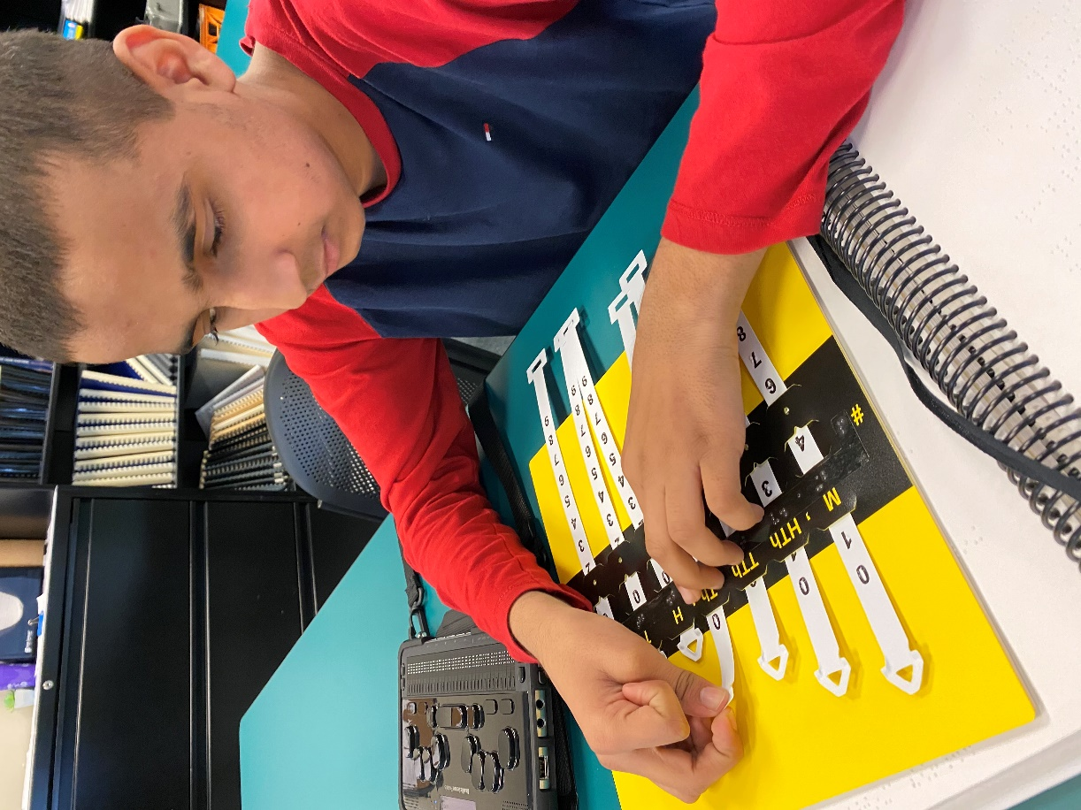

The Future
By Jessica B.

Students love getting a job. It’s the most exciting thing to get paid, spend it, and buy whatever you want. On-campus jobs at Overbrook are important. You can learn many skills and they help you build your goals to get ready for the future

They are many on-campus jobs. One of them is the Snack Bar. High school students can work there and it’s open on Wednesdays and Fridays. The second one is the Workshop. High school and school to work students can work there. You can do recycling, sell newspapers, or shred paper. They are open from 9:00 am-2:30 pm on Mondays through Fridays.

Jobs on campus help you learn skills. One of the skills is money. It is very important to learn how to spend your paycheck wisely and how to budget it. You must know how to count money, so you won’t get cheated and so that you can give customers the right change. Other skills you must learn are social skills. It is very important because you have to talk to your team or coworkers. If you have a difficult time with social skills, you should tell your team or coworker that you are still practicing. It’s important to speak up in the workplace! The last skill you can learn is living skills. This is very important because they will help you get ready for the future. I hope you learn a lot of things in the workplace.

Working on campus is important because it helps you build your goals. Goals are important in the workplace. Working helps you accomplish them one by one. Getting ready for the future is a big thing. You must learn a lot of skills. Getting your skills will help you to be successful and ready to graduate.

If you want to learn more about on-campus jobs, you can talk to high school and school to work kids about them or a teacher who works there too. Remember, learning new skills is not a bad thing. It’s a good thing. Try to keep up with your goals. It’s important for the future so you can be independent and successful.

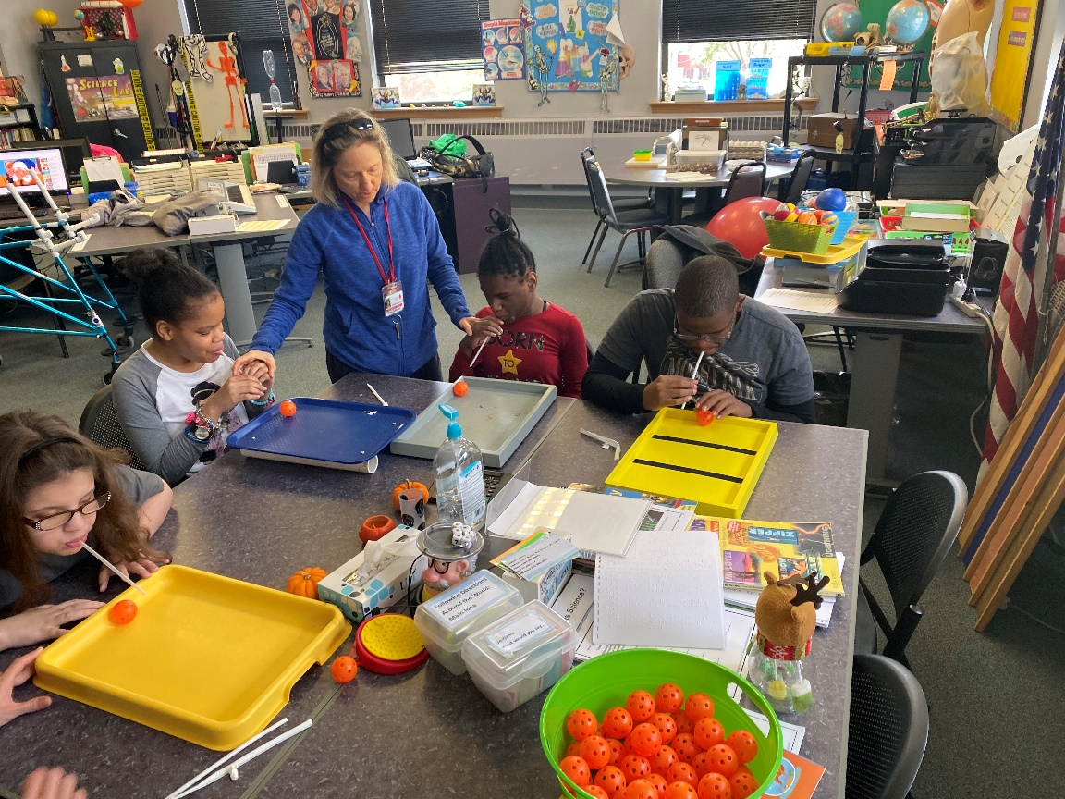

The Dangers of Smoking
By Angel
Smoking cigarettes is a very bad habit. You should never start smoking to begin with. Why do people do it? It may look fun and cool, but the results are never good. It is bad to smoke because it can cause a lot of health problems. It is also bad because people start to like it very fast. People smoke to the point that they cannot quit.

People smoke because they think it is fun or because they see someone else doing it like a family member or friend. People use smoking to calm down or if they are feeling depressed. People also do it because they say it makes them feel good. These are not good reasons to start smoking because it is very bad for your health. Teens and adults should find other ways to help them relax and feel good such as exercising, spending time with family and friends, and managing stress.

Smoking can give you cancer and you will live a less healthy life. Smoking is also very bad for your lungs. Smoking can cause bronchitis and emphysema. It has very bad chemicals that can affect your body.

You can avoid these health problems by not smoking or even thinking of doing it. You should always avoid smoking, no matter the cost. It is a thing you should never do. If your friends try to pressure you into trying a cigarette, remember that it is not worth it.

Smoking can put you in a lot of danger. It is not fun to do or to have the health problems that a smoker does. You would not want to do that to your body. You will not enjoy it. Try to live your life without smoking because it is a habit that is hard to quit.

The Power Between Our Love
By Breanna A.

Once upon a time there was a 20-year-old girl named Audrey and she had multiple powers. Her main power she used every day was to cure people that are very sick. Audrey always had her multiple powers ever since she was born. When Audrey was little, the main power she used every day was to make people smile just like she did every day.

One day when Audrey was out shopping, she met a 21-year-old boy named Adam who also had multiple powers just like her. His main power he used every day was changing bad people into good people. Adam had multiple powers ever since he was three years old. When Adam was little, his main power was to help people get along.

That same day Audrey and Adam talked for a little while and got each other’s phone numbers. They found out they had something in common: both had multiple powers. They talked more on the phone. The two of them talked every day and got to know each other more and grew closer.

One day Adam finally decided to ask Audrey out on a date, and she said yes. On their date, they went out to a fancy restaurant, but Adam also had another surprise spot to take Audrey. When they were done eating, a mission came up that they had to do together so Adam could not take Audrey to the surprise spot.

Audrey got an alert through her phone that there was a little girl in the hospital named Angel and she was very sick. So, both of them rushed to the hospital. When they got there Adam noticed that there was another problem and the doctors were being very rude to Angel and her family. So, Audrey went over to Angel and cured her. Adam walked over to the doctors, shook their hands to put them in their place and he change their ways, and everything went perfectly.

Audrey and Adam said, “And that’s why the power between our love will never end.”
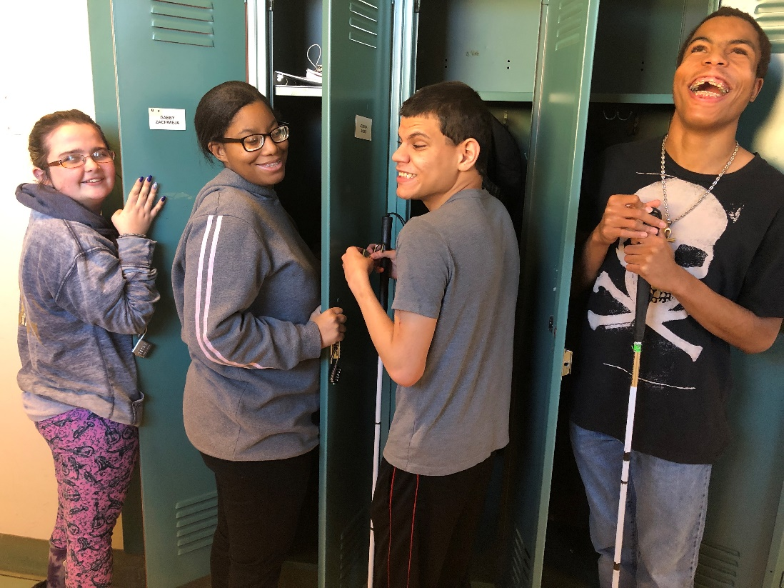

Jake and Lily Book Review
By Josmaidy

Author: Jerry Spinelli

Illustrator: (no illustrator)

Setting: starts outside, at a train station.

Main characters:

- Lily
- Jake

Description of Jake: Jake is the oldest by 11 minutes. He was born on a train in the Moffat Tunnel which goes under the mountains of Colorado. His birthday is on July 29th. He seems very competitive, outgoing and a little dramatic. Jake often misses the point of view. He’s not the brightest of the two twins. He is Lily’s twin brother.

Description of Lily: Lily is the youngest of the twins. Her birthday is on July 29th. Lily is very impatient, but she is also laid back and funny. Lily seems to be more descriptive. Lily was born on a train in the Moffat Tunnel under the mountains of Colorado.

Summary: In the beginning of the story it starts when they are both sleep walking in a train station as they are sharing the same dream. They are talking about how their lives started and the crazy coincidences that lead them to realize that they are not regular twins. Jake and Lily were born on a train in Colorado. Once Jake and Lily woke up from their dream, Jake and Lily were preparing for a special day. It was their birthday! They were having a party in their backyard and some guests came! Their dad was grilling food on the grill. The cake was pink and blue. Jake gave Lily a nice train as a birthday gift she didn’t even know she wanted! Since it was also Jakes birthday, Lily gave her brother a nice rock since Jake was a stone collector. There was this strange uninvited kid with a mohawk named Bump. He was trying to be nice and found a random muddy rock and decided to give it to Jake for his special day. Lily got offended because he wanted to give her brother a disgusting looking stone. She told her dad to kick him out, but her father told her to be nice. They decided to play hide and seek.

Moral of the story: In my opinion, the moral of the story is it’s the thought that counts. I say this because Bump came to the party unexpectedly and noticed that Jake was a stone collector. He didn’t have much money, so he gave Jake a muddy stone and even though it wasn’t much, it’s the thought that counts.

Conclusion: In conclusion, the kids were continuing to have fun at the party.

Rating of the story: I feel like this is a very enjoyable story. This could be relatable to many who may have a sibling (s). It’s a very excellent story so far. I would recommend this book to a friend because it’s an attention seeking book and I feel like my friends would enjoy it.

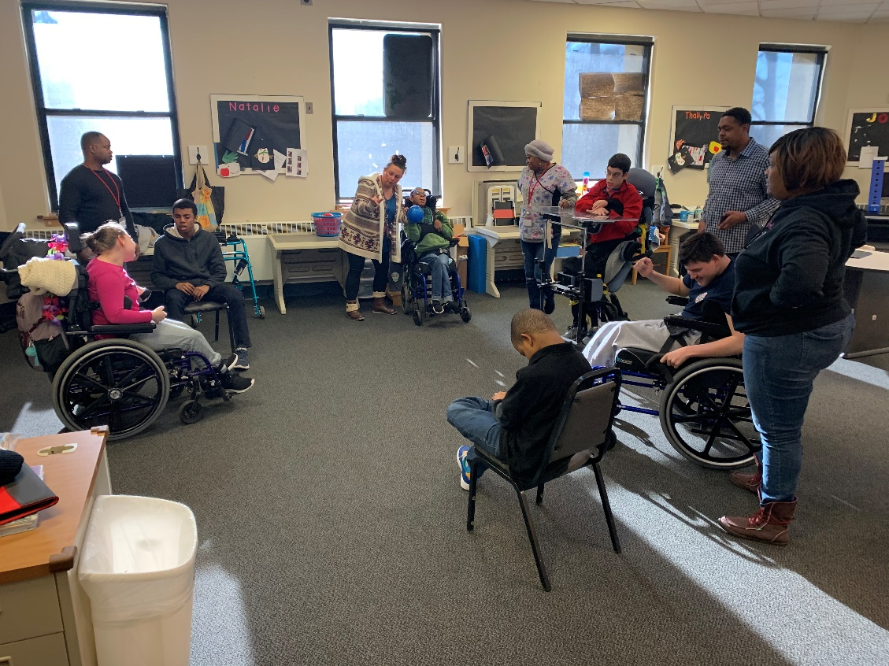

The History of Football
By Louis
Football is the most popular sport in America. Most people love it but how many people actually know how the sport was created? It’s actually a relatively new sport. The first game was just played in 1869. The sport didn’t start to gain popularity until the mid-1870s and the NFL wasn’t formed until 1922.
Football originated from soccer and rugby. It started as a modified version of soccer that was gaining popularity in America. This game was played by students from Rutgers and Princeton. The first game was played on November 6, 1869. Rutgers won 6-4, but that first game of football was nothing like the way the game is played today.
In 1873 Harvard started their own team but they couldn’t find a team to play with, so they invited a team from Canada to play with them. In the pre-game the Harvard students noticed that Canadian students played football in a completely different way. Both teams agreed that they liked the Canadian version better. After the game, Harvard took the game to Yale and other colleges started playing. That’s how the Harvard vs. Yale rivalry began. At this time a man named Walter Camp who was a student at Yale started playing football. While playing football at Yale he came up with many of the rules and regulations used in football today. After Walter Camp many of the other famous football players you know came along and further changed and modified the game
On September 17, 1920, the owners of professional football teams met to form the American Professional Football Association (APFA). They became the NFL two years later. Afterwards they created the NFL Championship game. A second league was created called the AAFC in 1944 but they merged with the NFL in 1949.
Football was originated from soccer and rugby. The first game was played on November 6, 1869. Harvard brought football to Yale and other schools started playing. The man who changed football into what we see today is Walter Camp. The APFA was created in 1920 and became the NFL two years later. That’s the history of the sport we call football.
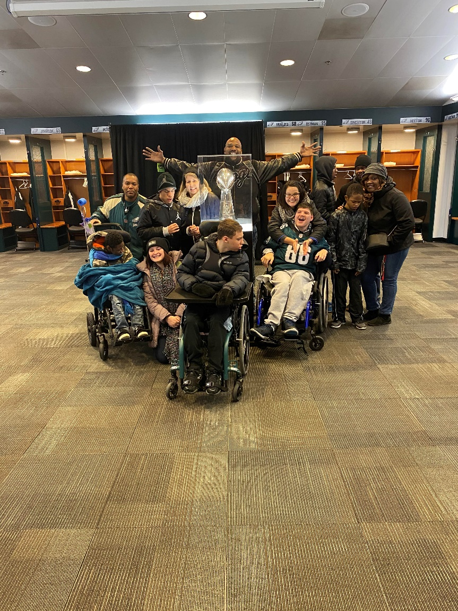

Magic is in The Air
By Ny’Aziah
A long time ago people believed in magical creatures such as vampires.
In the year 1020 there were five siblings named Nickclues, Elijah, Rebeca, Cole and Freia Michelson. They were born in England. When they were teenagers their mother was a witch and she turned them into vampires. They were the first vampires ever but there was a problem when their mother turned them into vampires. Nickclues was also a werewolf so when he turned his werewolf side came out. After his father found out, he was mad because their dad is human.

Keep an eye out for our Spring Newspaper to read the next part of this story!
